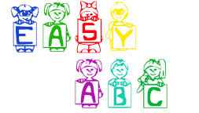

EasyABC APP

Documentation

Christian D. Moscosa

Android application

**History**

Why I decided to create this app?

The reason why I inspire to create this app is for my younger sister age 3 years old, she loves to play mobile game on my phone. Now she is my beta tester for this app and we both learn about something new and fun.

I continue to develop this app in the near future, this app is namely EasyABC or EasyLearning, this app it suitable for kids ages 3-5 years old.

I love android so I take this as my hobby and also I learn more about android by doing some more research.

**Introduction**

**Purpose of the Application**

Nowadays mobile phones and technologies had become wider and wider, the traditional way of doing things converted and developed in the latest technology trends. Specially the Children`s, they are affected to the changes that the technologies experience to us.

So then I decided to create an app that most of the kids especially children can use it for the foundation of their basic school lessons like alphabet, letters and shapes.

**Technologies/Platform used**

For this project I proposed to use android platform since I`m using this for now and I see a potential to market and update it soon as I learn it from time to time. (ADT)

* Android Developer Tool
* Photoshop (for layout)
* Mp3 decoder (for sounds)

**App icon**

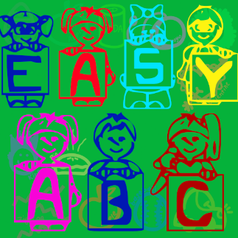

**Look and Feel of the App**

This is the main user interface of my app,

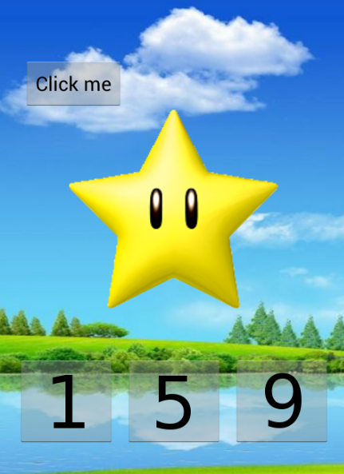

9

This is the basic main menu of my app, basically I used colorful background because it looks nice and catchy by the kids, but I need to improve the user interface. It has a three tab, the Alphabet, Numbers and lastly the Shape tab.

Each of them has a game or a window when it click or triggered, I also plan to add some sound effects when the button is clicked and then follow up by the next window or an activity. Since I am newbie at Java back then I was developing sites using PHP and then now I need to study some API`s and functions of android but I`m taking it as a hobby not a induced study or slowly but surely.

**Target of the audience**

The main user of this app is children specially kids to support their basic knowledge in counting, familiarizing with basic shapes and colors.

**How do I intent to monetize my app?**

I add some unlockable, like pay the full version to unlock more alphabets or instances, so the app can have some profit for the development, I also need to study some management fundamentals to make this app running and expand.

**How much this app cost?**

The user can download it free since I add pay to unlock more stuffs.

**Development**

# I want this app to be done as much as I can, so that my first tester for this app is my little 3 years old sister. I downloaded some apps that`s look like my app but then I cannot find the thing that I want, something that encourage the children to simply not to take it as a game but a reference and for their basic learnings.

**Conclusion**

# I`m happy to build an app, I know that there are so many app there that are great and much better to my project app but I know that this helps me to be more productive. The technology now are extending by simply invading the community by the mobile apps.

# I learn more in doing this app, I challenge myself to finish this and so be it, I hope you enjoy my little app and please email me at [shurikit@gmail.com](mailto:shurikit@gmail.com) if you see some bugs. Thanks!

**Site reference:**

<http://www.pond5.com/sound-effects-music/1/correct.html>

<http://www.dafont.com/>

<https://kuler.adobe.com/#create/fromacolor/>

<https://www.google.com.ph/>

<http://www.grsites.com/archive/sounds/>

Music by: Lullatone

Background by: Deviatart